# Links to Videos and Articles

[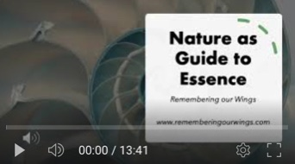](https://youtu.be/A6YRRVVAvTk)

Enjoy a meditative journey into essence with the natural world as your host and guide.

<https://youtu.be/A6YRRVVAvTk>